Round-Robin CPU Scheduling Simulator Using Circular Linked List
1. Title
Round-Robin CPU Scheduling Simulator Using Circular Linked List
2. Problem Statement
Develop a Round-Robin CPU Scheduling Simulator using a Circular Linked List in C++. The system should allow the user to enter processes and their burst times, set a time quantum, and simulate CPU scheduling. It should display the execution order, waiting time, turnaround time, and average waiting and turnaround times for the processes.
3. Objective
To understand the concept of a Circular Linked List.
To understand the Round-Robin CPU scheduling algorithm.
To create and manage process nodes dynamically.
To execute processes using a fixed time quantum.
To display the order of process execution.
To calculate waiting time and turnaround time.
To understand the practical use of linked lists in operating systems.
4. Algorithm
Step 1: Start the program.
Step 2: Create a Process node containing process ID, burst time, remaining time, and a pointer to the next node.
Step 3: Initialize the circular linked list as empty.
Step 4: Enter the process details and add each process to the circular linked list.
Step 5: Enter the time quantum.
Step 6: Set the current time to zero and begin with the first process.
Step 7: If the current process has remaining time, execute it for the smaller of the time quantum and its remaining time.
Step 8: Update the current time and the process's remaining time.
Step 9: If the process is not complete, move to the next process. If it is complete, record its completion time.
Step 10: Repeat the scheduling cycle until all processes are completed.
Step 11: Calculate turnaround time as completion time minus arrival time, and waiting time as turnaround time minus burst time. For this basic version, all arrival times are assumed to be zero.
Step 12: Display the execution sequence, waiting time, turnaround time, and average times.
Step 13: Stop the program.
5. Flowchart
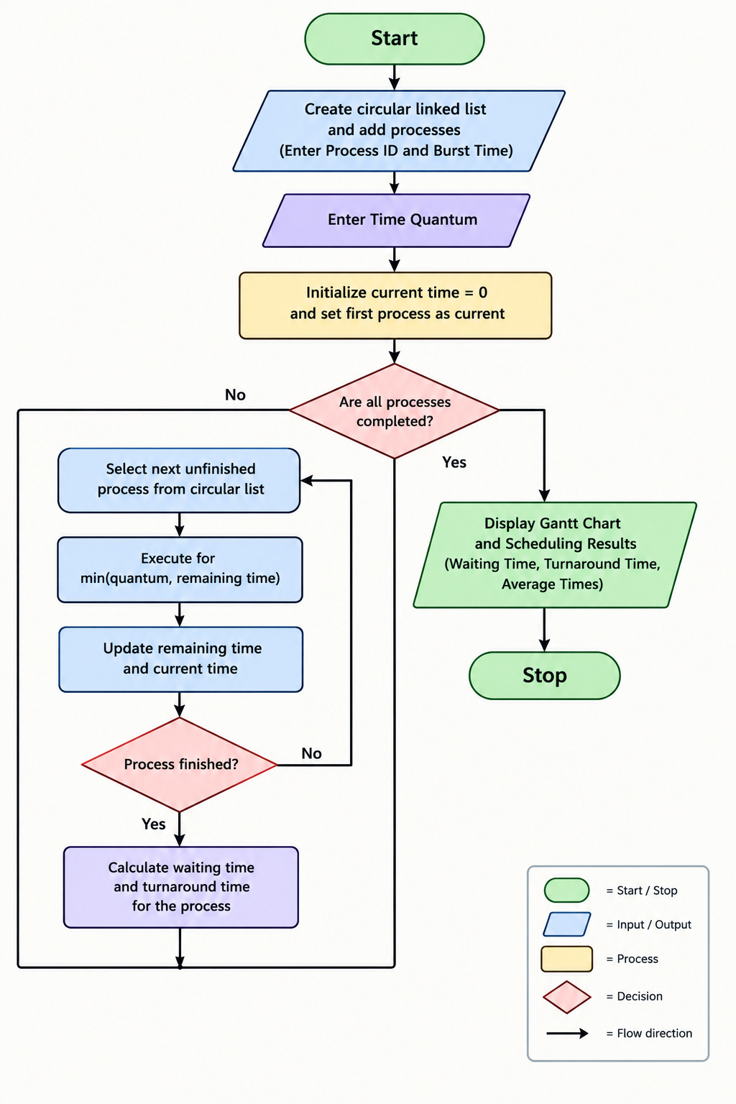
6. Conclusion
The Round-Robin CPU Scheduling Simulator demonstrates how a Circular Linked List can be used to manage processes in a repeating order. It simulates CPU execution using a fixed time quantum and calculates waiting time and turnaround time. This project helps in understanding linked lists and the basic working of CPU scheduling.

